2026 FIFA World Cup Analysis Project Report
Excel and Data Analysis
By Sayan Patel

Contents
Executive Summary: 3
Expected Finishes and Analysis – Group Stage: 4
Expected Finishes and Analysis – Knockout Stage: 6
Player Data: 8
Player Analysis: 11
Player Analysis - Top Scorers 12
Player Analysis - Most Efficient Scorers 13
Player Analysis - Most Used Players 14
Player Analysis - Goal Contribution Leaders 16
Player Analysis - Discipline Leaders 18
Player Analysis - Summary 20
Player Statistics: 21
Player Statistics - Overview: 22
Player Statistics – Goals vs Appearances 24
Player Statistics – Goals vs Assists 26
Player Statistics – Goals/Appearances vs Appearances 28
Player Statistics – Summary 30
Player Regression 32
Conclusion and Limitations 34
Conclusion 34
Limitations 35
Future Development 36
Data Sources and Collection 37

Executive Summary:
The purpose of this project was to analyse the 2026 FIFA World Cup using team and player data in Microsoft Excel.
Team analysis compares pre-tournament rankings with actual group finishes and uses expected positions to create a hypothetical knockout pathway, while player analysis focuses on goals, assists, appearances, scoring efficiency, attacking contribution and discipline.
Also, 25 of 48 teams (52.1%) finished in their expected group position, while goals had a positive correlation of 0.36 with both appearances and assists.
However, the findings also show the limitations of using a small number of variables to explain performance. Regression analysis found that an additional appearance was associated with around 0.14 additional goals, but the R² of 0.127 shows that appearances explained only a limited amount of the variation in goals.
The ranking analysis also provides a useful comparison between expected and actual progression but cannot account for individual match results or unexpected outcomes.
Overall, the project demonstrates how Excel can be used to combine data organisation, formulas, rankings, statistical analysis and visualisation to investigate football performance while also recognising the limitations of the available data.

Expected Finishes and Analysis – Group Stage:
Pre-tournament rankings were used to establish an expected finishing order for each of the 12 groups, with the four teams in each group ranked from first to fourth.
These expected positions were then compared with the teams' actual group-stage finishes, allowing the analysis to measure whether teams performed in line with expectations or finished higher or lower than their initial ranking suggested.
The difference measure makes this comparison easier to interpret, with positive values representing teams finishing above expectation and negative values representing teams finishing below expectation.
Across all 48 teams, 25 (52.1%) finished exactly where expected, while 11 finished above their expected position and 12 finished below it. Groups C, F and J were particularly consistent with the initial rankings, as all four teams in each group finished in their expected positions.
The largest movement was two positions, with South Africa and Cape Verde finishing above expectations and Turkey finishing below theirs.
These results show that pre-tournament rankings provided a reasonable basis for comparing expected and actual group performance, but they did not fully explain how the groups would finish.
A ranking gives an indication of relative strength before the tournament, whereas the actual group standings are affected by results across individual matches.
This makes the comparison useful for identifying where expectations were met or challenged without treating the rankings as a prediction of the final standings.
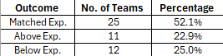

Table 1 - Summary of actual group-stage finishes compared with pre-tournament expectations

Expected Finishes and Analysis – Knockout Stage:
The knockout-stage analysis uses the pre-tournament rankings and expected group finishes to create a hypothetical pathway through the knockout rounds.
Teams are placed into the bracket based on where they were expected to finish in their groups, rather than their actual group positions, allowing the expected pathway to be compared with the teams that progressed.
The Round of 32 showed the largest difference, with 18 of 32 expected teams following the ranking-based pathway and 14 differing from it. This became 9 of 16 in the Round of 16 and 4 of 8 in the quarter-finals, before all four expected teams reached the semi-finals. The third-place play-off and final also showed differences, with Spain reaching the final instead of France.
These results demonstrate that pre-tournament rankings can provide a structured expectation for knockout progression, but they cannot account for individual match results and unexpected outcomes.
A single result can change the subsequent route through the bracket, meaning the pathway is better viewed as a hypothetical comparison rather than a prediction of the tournament outcome.
The results highlight how closely tournament progression can follow pre-tournament expectations in some stages, while unexpected results can quickly alter the pathway.
Therefore, this provides a useful way to assess the reliability and limitations of ranking-based expectations when applied to a knockout tournament.

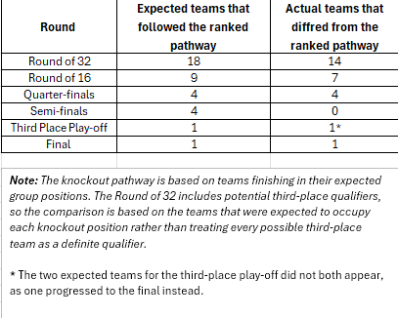

Table 2 - Comparison of expected and actual knockout-stage progression

Player Data:
The Player Data sheet organises the individual player data and adds several calculated measures to make comparisons easier.
The player number links each player back to their corresponding individual group sheet, making it possible to trace the player data back to the original tournament information.

The additional columns provide a more detailed view of player performance:
- Goals/App, measures scoring efficiency
- Goal Contribution, combines goals and assists
- Total Cards, records a yellow and red cards total
- Substitution Rate
- Goals/Start &Goals Rank, provide further calculated information for each player

Substitution Rate measures the proportion of a player's appearances in which they were substituted.
This helps show the difference between players who regularly completed their matches and those who were more frequently taken off.
However, the figure does not explain the reason for a substitution, as this could be influenced by tactical decisions, fitness, the match situation or the player's role.

Goals/Start compares a player's goals with the number of matches they started.
This provides another way of measuring scoring output by focusing on starts rather than total appearances, which can be particularly useful when comparing players who were regularly used from the bench.
A higher value indicates more goals relative to the number of starts, although the measure can be affected by players with only a small number of starts.
Goals Rank provides a unique ranking for every player based on their total number of goals.
Where players have the same number of goals, their names are used to separate the rankings so that every player receives a distinct position.
For example, Kylian Mbappé, with the highest goal total in the dataset, would receive rank #1, while Lionel Messi would receive #2 based on having the next highest total.
This creates a consistent ranking system across the dataset and makes it easier to order players when using the data in other parts of the workbook.
These calculated measures were then used in the Player Analysis sheet to create rankings and analyse different types of player performance.
The sheet therefore provides the main dataset for the player analysis, while keeping the original player information connected to the individual group sheets.
Therefore, the structure makes it easier to compare players using both their basic tournament statistics and the additional performance measures calculated in Excel.

Player Analysis:
The Player Analysis sheet brings together the player data and uses several different measures to compare performance during the tournament.
Rather than focusing only on total goals, the analysis considers scoring efficiency, appearances, goal contributions and discipline to provide a wider view of how players performed.
Each section focuses on a different performance indicator, with rankings for Top Scorers, Most Efficient Scorers, Most Used Players, Goal Contribution Leaders and Discipline Leaders.
The tables also include additional statistics such as appearances, starts, assists, Goals/App and Cards/App to give more context to each ranking.
Using these measures allows players with different roles and styles of play to be identified.
A player may stand out for their goalscoring, while another may contribute more through assists, regular appearances or other aspects of their tournament involvement.

Player Analysis - Top Scorers
The Top Scorers table ranks players according to their total number of goals during the tournament.
This provides the simplest measure of attacking output and highlights the players who were most successful at putting the ball in the net.
Kylian Mbappé leads the ranking with 10 goals, followed by Lionel Messi with 8. Jude Bellingham and Erling Haaland both recorded 7 goals, placing them among the highest-scoring players in the tournament.
The ranking also provides a useful starting point for comparing total goals with other measures.
For example, Mbappé scored 10 goals across 8 appearances, while Haaland scored 7 from just 5 appearances, showing why total goals and scoring efficiency can give different views of player performance.
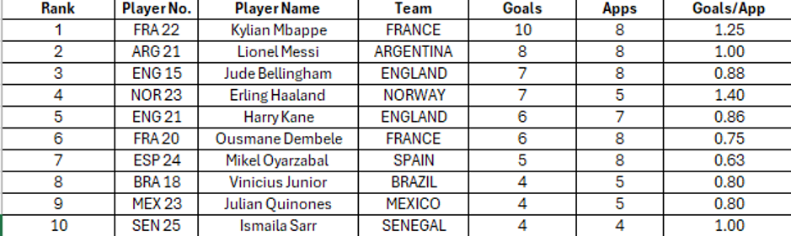

Table 3 - Top 10 players ranked by total goals

Player Analysis - Most Efficient Scorers
The Most Efficient Scorer’s table uses Goals/App to identify players who scored at a high rate relative to the number of appearances they made.
This gives a different result from the standard goals ranking because a player with fewer appearances can still have a very high scoring rate.
A minimum of three appearances was used here to reduce the effect of players who only appeared once or twice, making the comparison more useful and less influenced by very small samples.
Unlike the Top Scorers table, which ranks players by their total number of goals, the Most Efficient Scorer’s table uses goals per appearance to measure how regularly players scored when they played.
This changes the rankings significantly, with Erling Haaland moving to first place at 1.40 goals per appearance, despite having fewer total goals than Kylian Mbappé.
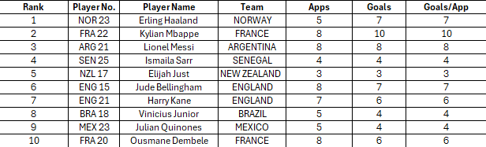

Table 4. Top 10 players by goals-per-appearance rate, among those with at least three appearances
Player Analysis - Most Used Players
The Most Used Players table focuses on appearances and identifies the players who featured most regularly throughout the tournament.
High appearance numbers can indicate that a player was consistently selected and played an important role for their team, although appearances alone do not show how productive they were.
In this table, several players made all eight appearances, showing how regularly they were involved throughout the tournament, while the ‘Starts’, ‘Sub In’ and ‘Starting %’ columns give some extra context around how those appearances were made.
For example, Emiliano Martínez, Pau Cubarsí and Marc Cucurella all made eight appearances and started all eight matches, giving them a 100% starting rate.
This contrasts with a player who may have made a similar number of appearances but had more substitute appearances, showing that simply counting appearances does not always tell the full story of a player's involvement.
This makes it possible to distinguish between players who were regular starters and those who made more of their appearances from the bench.
The table therefore gives a clearer picture of which players were consistently relied upon by their teams throughout the tournament.

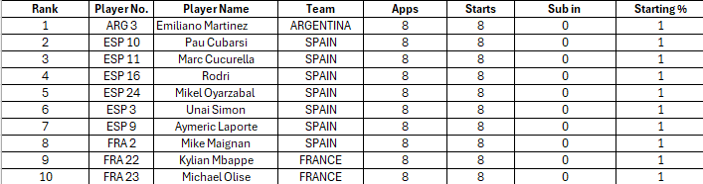

Table 5 - Top 10 players ranked by number of tournament appearances

Player Analysis - Goal Contribution Leaders
The Goal Contribution Leaders table combines goals and assists to measure each player's direct involvement in their team's goals.
This gives a broader view of attacking performance than goals alone, as players can contribute through both finishing chances and creating goals for teammates.
It also makes it possible to compare players with different attacking roles using the same measure.
Kylian Mbappé leads the table with 14 goal contributions, made up of 10 goals and 4 assists, while Lionel Messi follows with 12, recording 8 goals and 4 assists.
Another interesting example is Michael Olise, who ranks seventh with 7 goal contributions despite scoring no goals, as all seven came through assists.
This shows how the measure can highlight creative players who would rank much lower in a goals-only comparison.
The table also shows how players with similar goal totals can have different levels of overall attacking contribution.
Jude Bellingham and Harry Kane both recorded 8 goal contributions, but Bellingham achieved this through 7 goals and 1 assist, while Kane recorded 6 goals and 2 assists.
Erling Haaland also provides a useful comparison, with 7 goals but no assists, giving him 7 total contributions despite making only 5 appearances.
This makes goal contribution a useful measure for comparing different types of attacking involvement while also providing some context around how frequently players were involved.
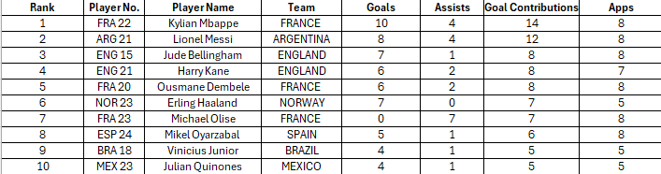

Table 6 – Top 10 players ranked by total goal contributions (goals and assists)

Player Analysis - Discipline Leaders
The Discipline Leaders table ranks players by their Total Cards, which combines yellow and red cards to give an overall measure of disciplinary incidents during the tournament.
Cards/App is also included to account for differences in the number of appearances, as a player who appeared fewer times may have a higher card rate despite having fewer total cards.
Enzo Fernández, Breel Embolo and Issa Diop all recorded 3 total cards, placing them joint at the top of the table based on the number of cards received.
However, their Cards/App figures differ, with Fernández recording 0.43, Embolo 0.50 and Diop 0.60, showing how the rate provides additional context based on their number of appearances. Issa Diop therefore recorded the highest card rate among the three despite having the same total number of cards.
The table also shows that several players received both a yellow and a red card during the tournament.

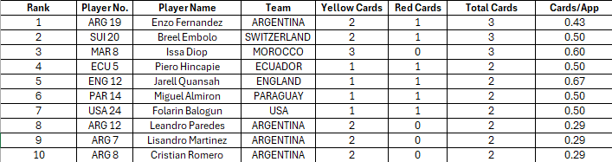

Table 7 - Top 10 players ranked by total cards, including yellow and red cards

For example, Piero Hincapié, Jarell Quansah, Miguel Almirón and Folarin Balogun each recorded 2 total cards, including one red card. This adds further detail to the total-card ranking, as the type of card received can provide more context than the total alone.

Player Analysis - Summary
The Player Analysis sheet brings together several different measures to give a broader view of player performance during the tournament.
The rankings show that different measures can produce quite different results, with players standing out for their total goals, scoring efficiency, number of appearances, goal contributions or disciplinary record.
For example, the Top Scorers ranking focuses on total attacking output, while the Most Efficient Scorers ranking can highlight players who scored regularly despite making fewer appearances.
Using these measures together provides more context than relying on a single statistic.
The inclusion of calculated measures such as Goals/App, Goal Contribution, Cards/App, Substitution Rate and Goals/Start allows player performance to be compared from several different angles, while the ranking tables make the results easier to interpret.
Overall, the sheet demonstrates how calculated Excel measures can be used to turn the original player dataset into clearer comparisons and identify different patterns in tournament performance.

Player Statistics:
The Player Statistics sheet looks at the player dataset from a statistical perspective, moving away from individual rankings and towards patterns across all players in the tournament.
Descriptive statistics are used to summarise appearances, goals, assists and goals per appearance, while correlation and $R^{2}$are then used to investigate relationships between different player variables.
This provides a clearer picture of how the data is distributed across the dataset and whether measures such as appearances are related to attacking output.
The first table provides a statistical overview of the 1,248 players included in the dataset.
Using the average, median, minimum, maximum and standard deviation makes it possible to see not only the typical values, but also how much variation exists between players.
This is particularly useful for this dataset because many players made relatively few appearances, while a much smaller number played regularly throughout the tournament.

Player Statistics - Overview:
The statistical overview summarises the main characteristics of the 1,248 players included in the dataset.
The average player made 2.58 appearances, while the median was 3, with appearances ranging from 0 to 8. This shows that player involvement varied considerably, with some squad members not appearing at all and a smaller group playing throughout the tournament.
The standard deviation of 1.92 supports this, showing a relatively widespread in appearances around the average.
Goals and assists were much more concentrated around zero. The average player scored 0.24 goals and recorded 0.18 assists, while the median for both measures was 0.
This indicates that at least half of the players recorded no goals or assists, which is reasonable given that the dataset includes players from all positions and players with limited or no playing time.
The maximum values of 10 goals and 7 assists show how much higher the attacking output was for the leading individual performers compared with the typical player.
The Goals/App. measure gives further context by looking at scoring relative to appearances.
Its average is 0.06, while the median is again 0, meaning most players did not score, whereas a smaller number recorded much higher scoring rates.

The maximum of 1.50 goals per appearance demonstrates the effect that a small number of appearances can have on a rate statistic, so this measure needs to be considered alongside total appearances rather than on its own.
Overall, the differences between the averages, medians and maximum values show that player performance is unevenly distributed, with a relatively small group accounting for much of the tournament's goals and assists.

Player Statistics – Goals vs Appearances
The Goals vs Appearances analysis examines whether players who appeared in more matches generally scored more goals.
The correlation of 0.36 indicates a positive relationship, meaning that higher numbers of appearances tend to be associated with higher goal totals.
However, the correlation is not particularly strong, so the data also contains many players whose goal totals do not closely follow their number of appearances.
The R² value of 0.13 provides another way of measuring this relationship. It indicates that approximately 13% of the variation in goals can be explained by appearances alone, leaving a large proportion that is related to other factors or not explained by this simple relationship.
This result also makes sense in the context of football, as appearances only show whether a player featured in a match and do not capture factors such as minutes played, position, team attacking strength, playing role or individual scoring ability.
A forward who regularly starts for a high-scoring team will have different opportunities from a defender or goalkeeper, even if both make the same number of appearances.
Therefore, the positive correlation suggests that greater involvement provides more opportunities to score, but the relatively low R² shows that appearances alone are not enough to explain individual goal output.

The scatter plot reflects this, with the observations spread considerably around the trendline rather than following a clear straight-line pattern.

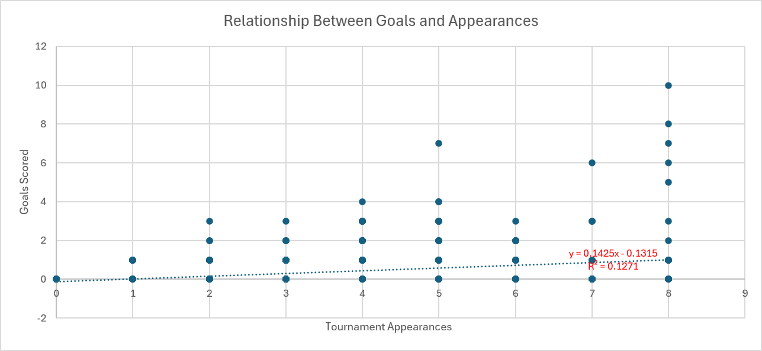

Chart 1 - Scatter plot showing the relationship between player appearances and goals scored

Player Statistics – Goals vs Assists
The Goals vs Assists analysis examines whether players who scored more goals also tended to record more assists during the tournament.
The correlation of 0.35 indicates a positive relationship, meaning that players with higher goal totals generally also recorded more assists.
However, the relationship is only moderate, showing that scoring and assisting are related to some extent but do not necessarily increase together for every player.
The R² value of 0.12 indicates that approximately 12% of the variation in assists can be explained by goals scored.
This is relatively low, meaning that goals alone provide only a limited explanation of why some players recorded more assists than others.
This relationship is also influenced by the different roles players have within their teams.
A player who is primarily responsible for finishing chances may score several goals without recording many assists, while a creative midfielder or winger may contribute more through creating chances for teammates.
For example, Erling Haaland recorded 7 goals but no assists, whereas Michael Olise recorded 7 assists but no goals, showing how two players can have the same level of total attacking involvement but contribute in very different ways.

Therefore, the positive correlation suggests some connection between scoring and creating goals, but the relatively low R² demonstrates that goals and assists measure different aspects of attacking contribution.
The scatter plot also shows considerable variation around the trendline, with players recording similar goal totals but quite different numbers of assists.

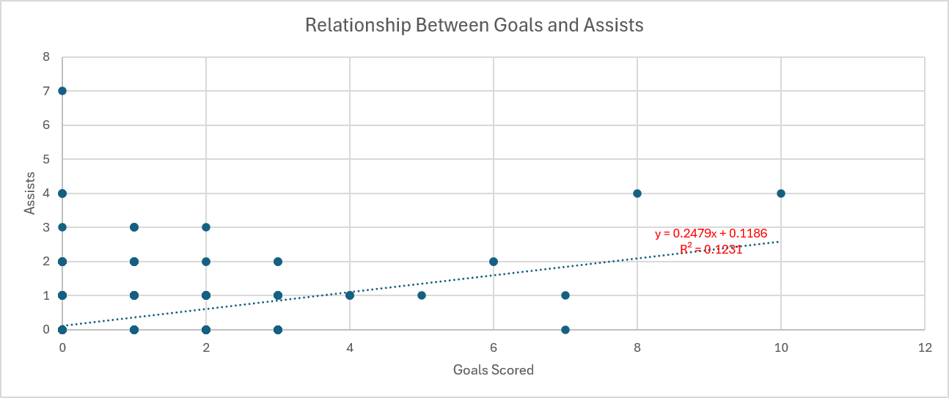

Chart 2 - Scatter plot showing the relationship between player goals and assists

Player Statistics – Goals/Appearances vs Appearances
This analysis examines whether the number of times a player appeared in the tournament was related to their goalscoring efficiency.
Appearances measure how many matches a player featured in, while Goals/App measures the number of goals scored per appearance.
Therefore, the analysis looks at whether players who played more matches also tended to score at a higher rate.
The correlation of 0.23 indicates a weak positive relationship between appearances and Goals/App. This suggests that players with more appearances tended to have slightly higher scoring rates, but the relationship is much weaker than the 0.36 correlation between appearances and total goals.
This is because total goals can increase simply through having more opportunities to play, whereas Goals/App measures scoring efficiency.
The R² value of 0.05 means that appearances explain only around 5% of the variation in Goals/App. This shows that the number of matches played has limited explanatory power when considering how efficiently players scored.
The result also highlights the importance of player roles and individual scoring ability.
A player can make many appearances without being a regular goalscorer, while another player with fewer appearances can have a much higher Goals/App rate.
The maximum value of 1.50 goals per appearance also shows why this measure should be considered alongside the number of appearances, as high rates can occur with relatively few matches.
The scatter plot also shows a wide spread of players around the trendline, supporting the weak relationship.

Chart 3 - Scatter plot showing the relationship between player appearances and goals per appearance

Player Statistics – Summary
The statistical overview shows that player involvement and attacking output varied considerably across the 1,248 players in the dataset.
The average player made 2.58 appearances, scored 0.24 goals and recorded 0.18 assists, while the median for goals and assists was 0.
This indicates that attacking output was concentrated among a smaller number of players, with the maximum values reaching 10 goals and 7 assists.
The relationship between appearances and goals was positive, with a correlation of 0.36 and an R² of 0.13.
This suggests that players who appeared more often generally scored more goals, but appearances alone explained only around 13% of the variation in goals.
The scatter plot supports this, as the players are widely spread around the trendline rather than forming a strong pattern.
Goals and assists also had a positive correlation of 0.35, with an R² of 0.12.
This shows that players who scored more goals tended to record more assists as well, although the relatively low R² indicates that the two measures still varied considerably between players.
Different playing roles help explain this, as some players contribute mainly through finishing while others are more involved in creating chances.
The relationship between appearances and Goals/App was weaker, with a correlation of 0.23 and an R² of just 0.05.
This suggests that playing more matches had only a limited relationship with scoring efficiency, highlighting the difference between having more opportunities to score and scoring at a high rate.
The results therefore show that appearances are more closely related to total goals than to Goals/App, while factors such as player position, role and individual ability are likely to have a greater influence on scoring efficiency.
Overall, the four sections show that simple statistical measures can identify useful relationships within the player data, but no single variable provides a complete explanation of player performance.

Player Regression
A simple linear regression was used to examine the relationship between player appearances and goals scored across the 1,248 players in the dataset.
Goals are treated as the dependent variable, while appearances are used as the explanatory variable.
This extends the correlation analysis by estimating how much goal output changes in relation to an additional appearance.
The appearances coefficient is 0.142, meaning that one additional appearance is associated with approximately 0.14 additional goals, on average.
This positive coefficient supports the relationship identified in the earlier analysis.
With a p-value of 1.07 × 10⁻³⁸, the relationship is statistically significant, providing strong evidence of an association between appearances and goals within the dataset.
Despite this statistical significance, the model has an R² of 0.127, meaning that appearances explain only around 12.7% of the variation in goals.
A significant relationship therefore does not mean that appearances are enough to explain individual goal-scoring performance.
Factors such as position, minutes played, team performance, playing role and individual ability are likely to account for much of the remaining variation.
Further information from the regression output supports the estimated relationship. The standard error is 0.719, while the 95% confidence interval for the appearances coefficient ranges from approximately 0.122 to 0.163.
Since the interval remains positive, it is consistent with the positive coefficient estimated by the model.
The residual and line-fit analysis also show considerable differences between actual and predicted goal totals.
Some players scored more than the model predicted, while others scored less, demonstrating that appearances alone cannot closely predict individual goal output.
Overall, the regression provides evidence of a positive and statistically significant relationship between appearances and goals, but its relatively low R² highlights the limitations of using appearances as the only explanatory variable.

Conclusion and Limitations

Conclusion
The analysis provides a range of insights into team and player performance during the 2026 FIFA World Cup.
At group stage level, 25 of 48 teams (52.1%) finished in their expected position, showing that pre-tournament rankings provided a useful benchmark, although actual match results caused several teams to outperform or fall below expectations.
The player analysis also showed considerable differences in performance, with goals, assists, appearances and scoring efficiency producing different rankings across the tournament.
Statistical analysis found positive relationships between appearances and goals, and between goals and assists.
The regression model supported the relationship between appearances and goals, with an appearances coefficient of 0.142 and a statistically significant p-value.
However, the R² of 0.127 showed that appearances alone explained only a limited proportion of the variation in goals, highlighting the importance of other factors when analysing individual performance.

Limitations
Several limitations should be considered when interpreting the results.
Player appearances do not show the number of minutes played, meaning a short substitute appearance is treated the same as a full match, while measures such as Goals/App can also be affected by players with relatively few appearances.
The analysis does not include other potentially important factors such as player position, shots, chances created, team attacking performance or tactical role, which could help explain differences in goal output.
Similarly, the pre-tournament rankings provide a useful benchmark for the team analysis, but the hypothetical knockout pathway cannot account for individual match results, injuries, tactical changes or unexpected performances during the tournament.

Future Development
There are several ways the project could be developed further using a larger range of data.
Adding minutes played, player position, shots, chances created and other performance measures would provide a more detailed picture of individual player contribution and could be used in a multiple regression model.
The team analysis could also be expanded by including measures such as goals scored, goals conceded, possession and expected goals, while comparing the 2026 World Cup with previous tournaments could identify longer-term patterns in team and player performance.
Further Excel techniques, such as more advanced Power Query transformations, interactive dashboards or additional statistical models, could also be incorporated as the dataset and analysis become more advanced.

Data Sources and Collection
The player and team statistics used in this project were collected and organised manually throughout the 2026 FIFA World Cup.
Match results, player appearances, goals, assists and disciplinary records were recorded after matches and then checked before being incorporated into the Excel workbook.
This provided the raw dataset used for the subsequent calculations, rankings and statistical analysis.
Pre-tournament team rankings were used as the basis for establishing expected group positions and the hypothetical knockout pathway.
These rankings were recorded before comparing them with the actual tournament results, allowing differences between expected and actual progression to be examined.
The collected data was then organised within Excel and processed using formulas and Power Query where appropriate.
Calculated measures, including Goals/App, Goal Contribution, Total Cards, Substitution Rate, Goals/Start and Goals Rank, were generated within the workbook rather than taken directly from an external source.
This helped maintain a consistent dataset and made the calculations traceable within the workbook.

